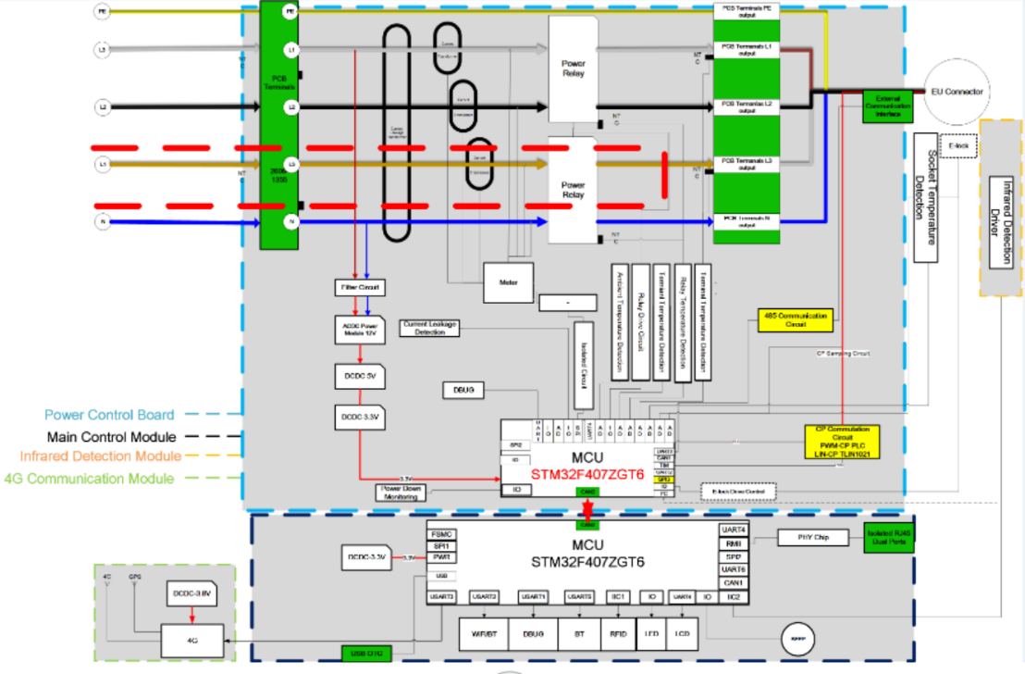

|  |  |
| --- | --- |
| Power Control Board | Leistungssteuerungsplatine |
| Main Control Module | Hauptsteuerungsmodul |
| Infrared Detection Module | Infrarot-Detektor-Modul |
| 4G Communication Module | 4G-Kommunikationsmodul |
| Socket Temperature Detection | Buchse Temperaturerfassung |
| Infrared Detection Driver | Infrarot-Detektor-Treiber |

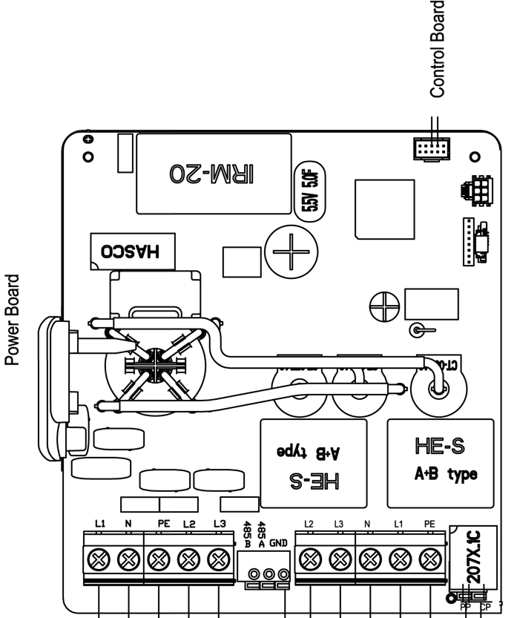

|  |  |
| --- | --- |
| Power Board | Netzteilplatine |
| Control Board | Steuerplatine |

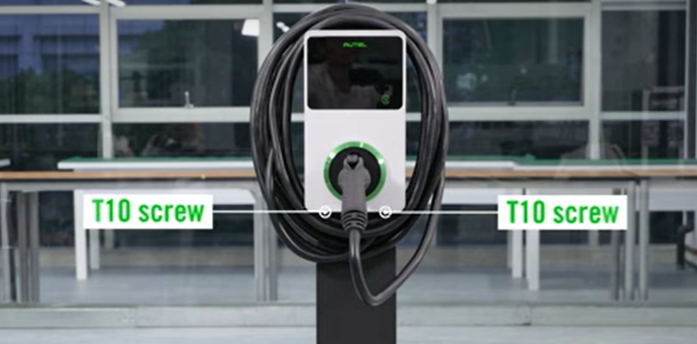

|  |  |
| --- | --- |
| T10 screw | T10-Schraube |

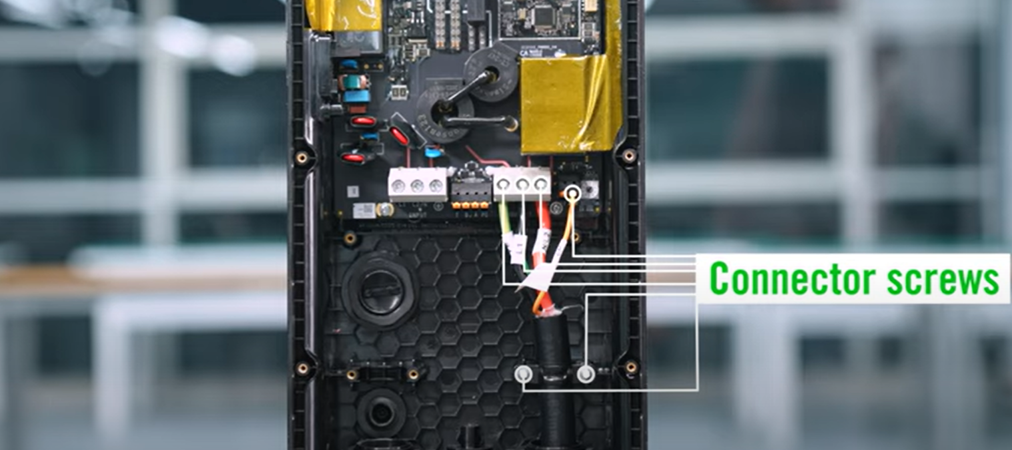

|  |  |
| --- | --- |
| Connector screws | Ladegriffschrauben |